Madonna Arts And Science College For Women

Project Report

Introuction:

Canva is Simply Outstanding As A tool to creat designs canva is such a seamiess experience that once onecan sit down to design and don’t feel like getting up. It’s addictive and useful.

* 1. Overview:

After gathering information for creating Cv in canva the user can find a Template and customize the design and can incorporate the vishal element by using icons or symbols to enhance the of Create A Social Madia Post. By using appropriate colour Palette and fonts from Typography I aling the personal branding and overall design for my project.

1.2.Purpose:

User taking this project will obtain tha ability to A Social Madia Post using this canva platform. The primary objective was to craft a modern professional social media post that would stand out to potential social media.

Problem Definition & Design Thinking:

2.1.Empathy:

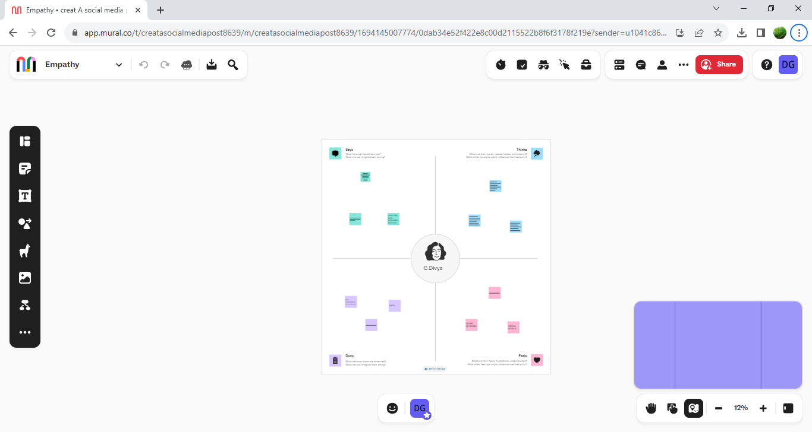

2.2.Ideation&BrainstormingMap: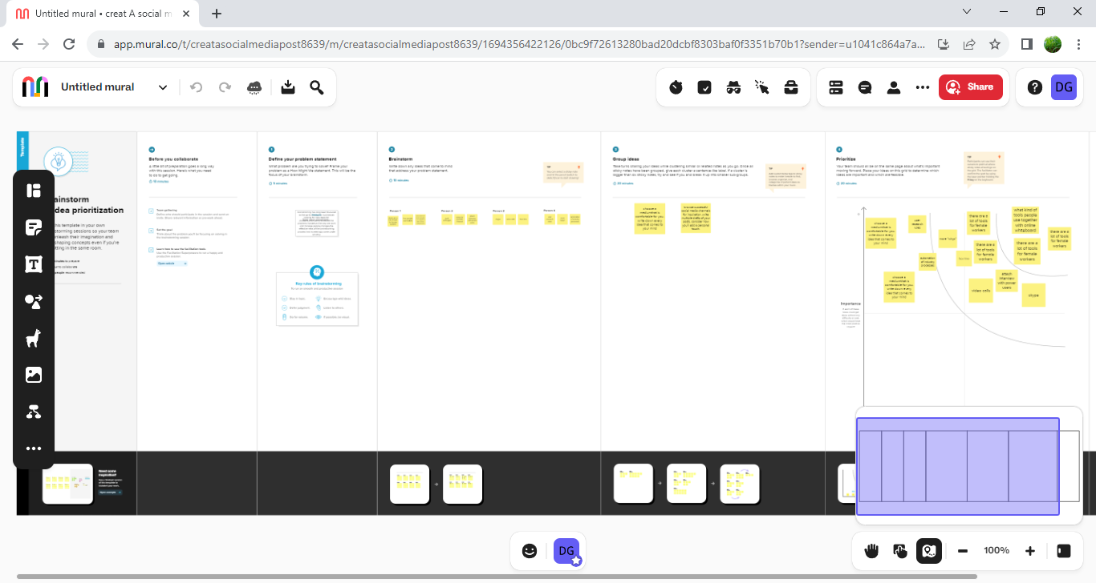

3.Result:

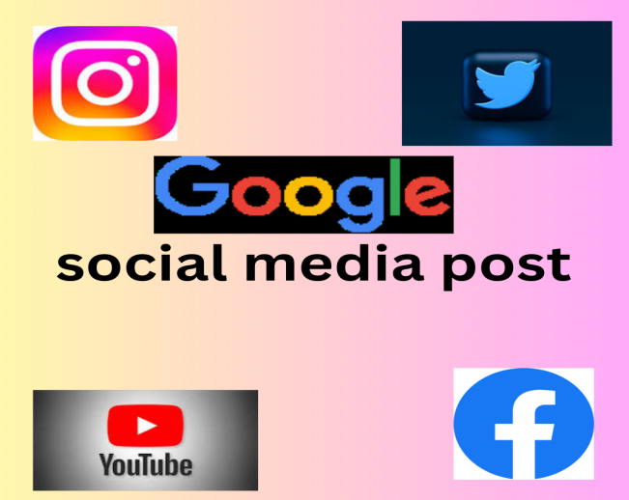

4.Advantages and Disadvantage

It has been an instrumental in securing job interviews and opportunities.

The social media stands out among competing candidates , demonstrating my design skills and attention to detail.

User can use only in the online mode.

5.Conclusion:

The Canva social media post Design project was a successful endeavour resulting in a modern and visually striking social media that effectively represent my professional profile. This project reinforced my design skills, attention yo detail, and abilty to create impactful visuals andcommitment to presenting myself professionally.